This presentation explores the weather conditions, including temperature, humidity, wind speed, and pressure.

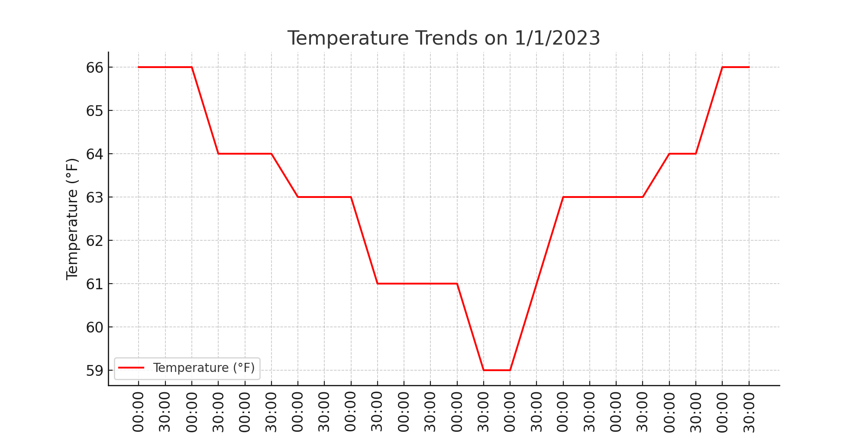

**Key Variables Analyzed**

Temperature: The temperature ranged from 59°F to 66°F.

Dew Point: The dew point ranged from 57°F to 63°F.

Humidity: Humidity was consistently high, ranging from 78% to 94%.

Wind: Wind speeds were generally calm, with occasional gusts.

Pressure: Barometric pressure fluctuated slightly between 30.00 to 30.12 Hg.

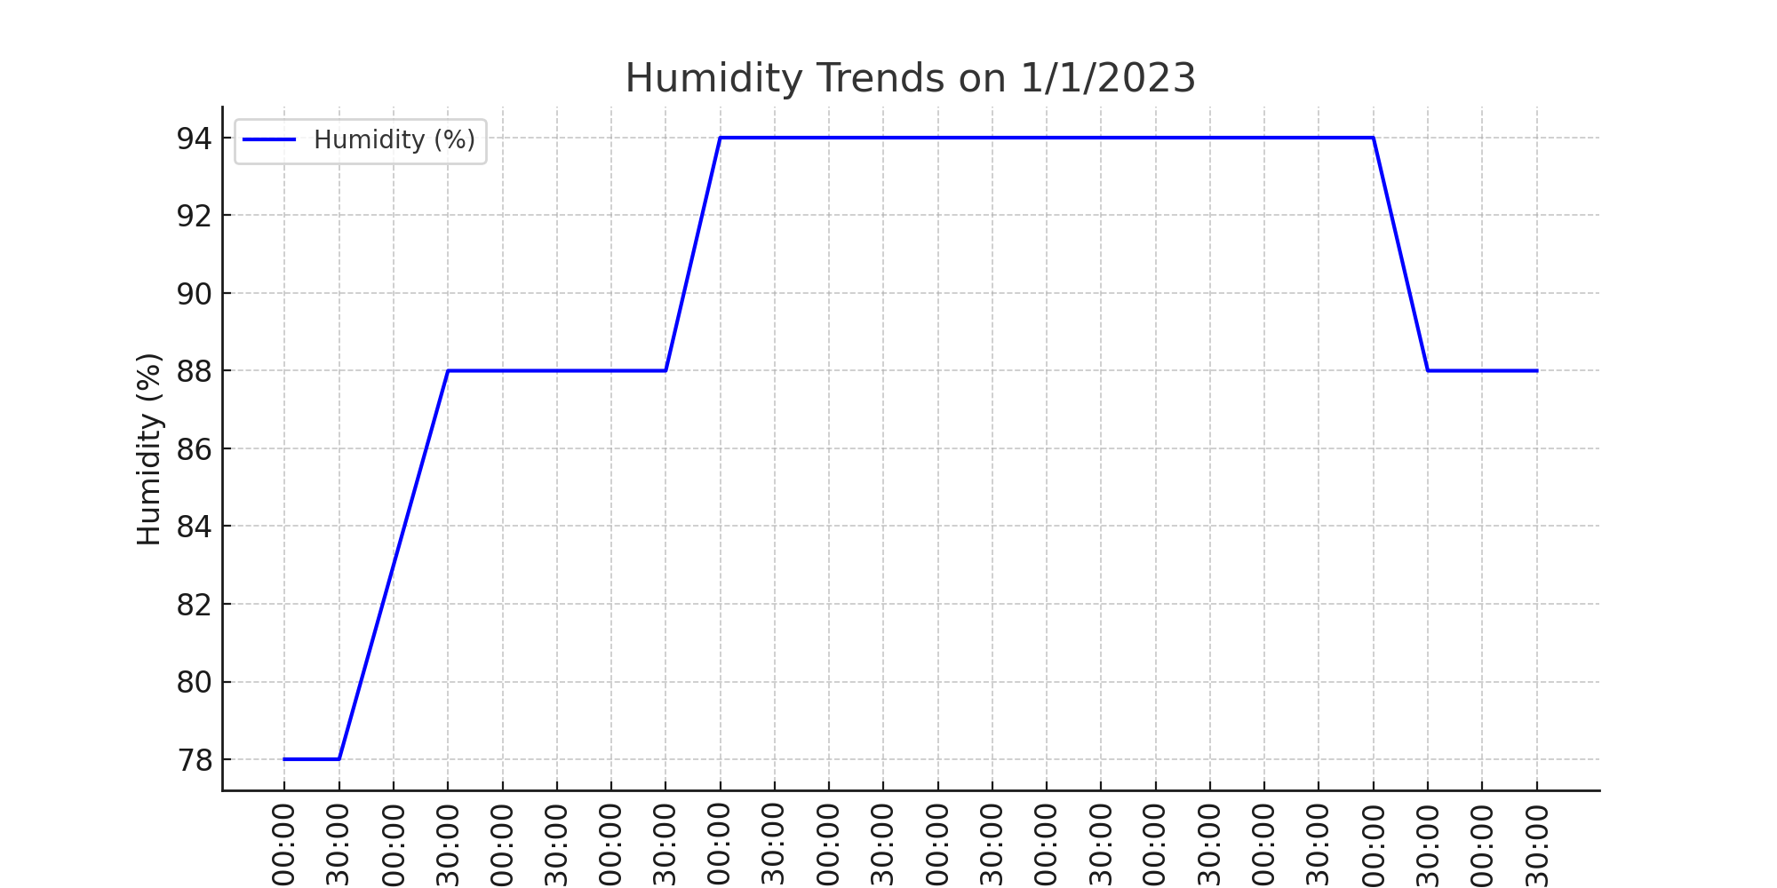

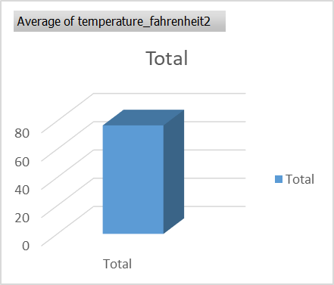**Wind Speed Variation** 

